**TASK1**

**// Command Line**

1. Print in terminal screen " **Hi, my name is..., and I’m software robotics engineer** "

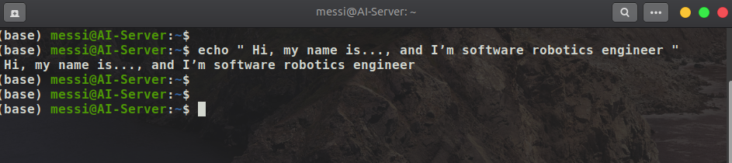

1. open **image**, run **Video**, open **browser**, open **pdf**. **FROM** Terminal command line.

- Open Image

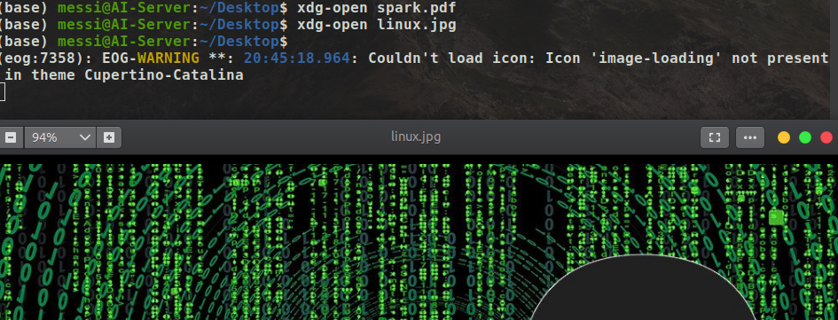

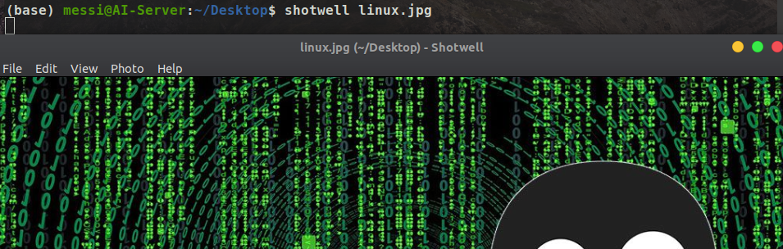

- Open Video

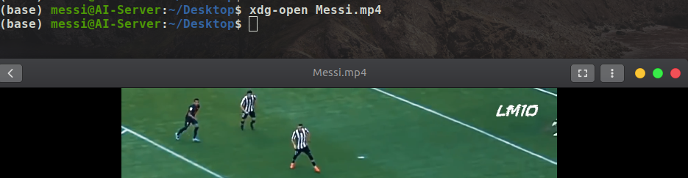

- Open PDF

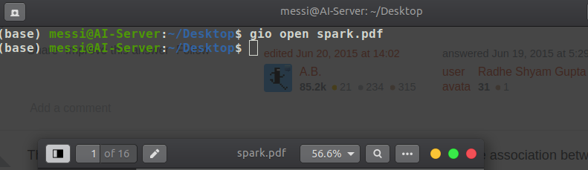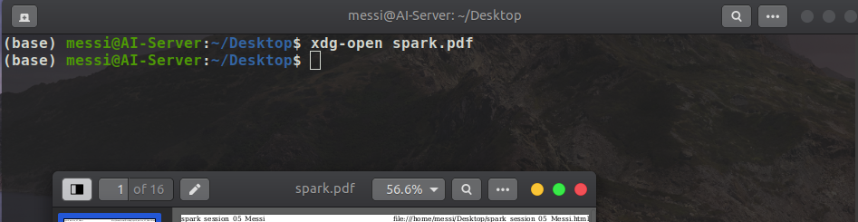

------------------------------------------------------------------------------------------------------------------

Note:

You can ask google..How i can print in terminal, How i can open image with terminal, run video,.....